|  |
| --- |
| cd app  md modules  cd modules  ng g module shared  ng g module public --routing  ng g module admin --routing  cd admin  ng g component cities  cd cities  ng g component cities-edit  └───app  ├───auth-guards  ├───endpoints  │ ├───auth-endpoints  │ ├───city-endpoints  │ └───country-endpoints  ├───helper  ├───modules  │ ├───admin  │ │ ├───admin-error-page  │ │ ├───admin-layout  │ │ ├───cities  │ │ │ └───cities-edit  │ │ ├───dashboard  │ │ ├───destination  │ │ └───reservation  │ ├───auth  │ │ ├───auth-layout  │ │ ├───forget-password  │ │ ├───login  │ │ ├───logout  │ │ ├───register  │ │ └───two-factor  │ ├───public  │ │ ├───about  │ │ ├───blog  │ │ ├───contact-us  │ │ ├───home  │ │ ├───public-layout  │ │ └───travels  │ └───shared  │ └───unauthorized  └───services  └───auth-services  └───dto |

# Angular moduli, komponente, lazy loading

# Endpoint interface

# Auth service i http interceptor

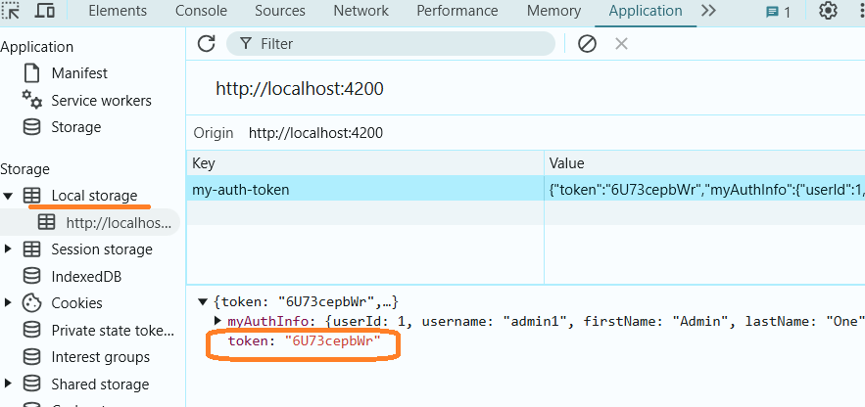

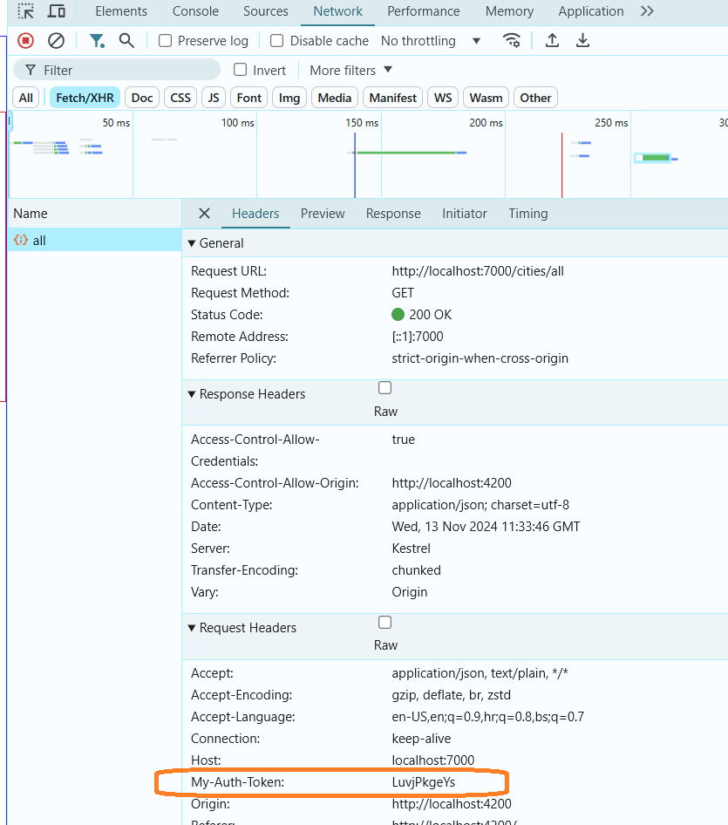

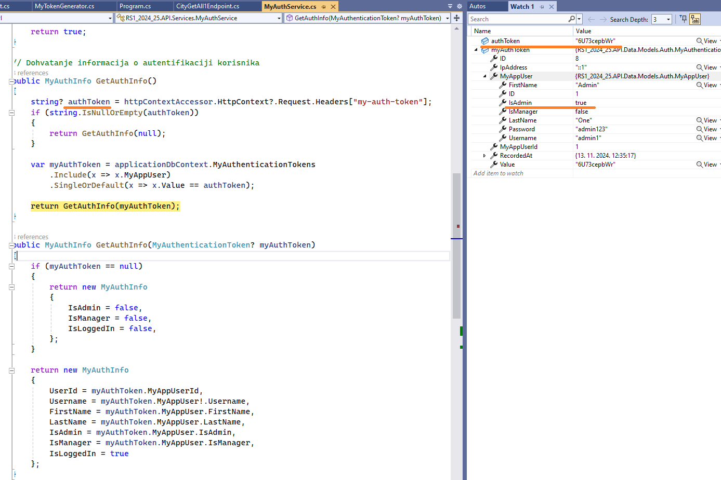

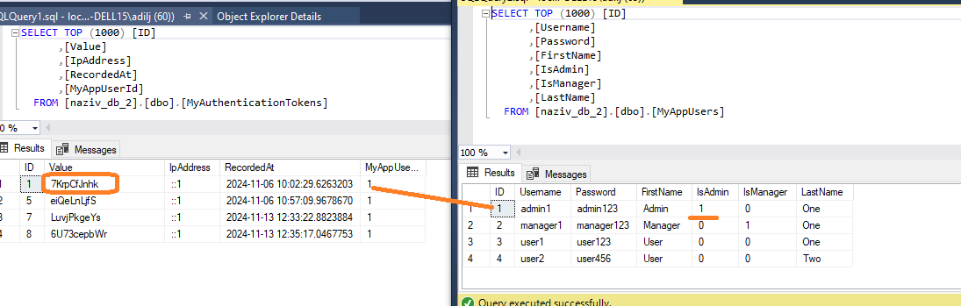

# AuthGuard

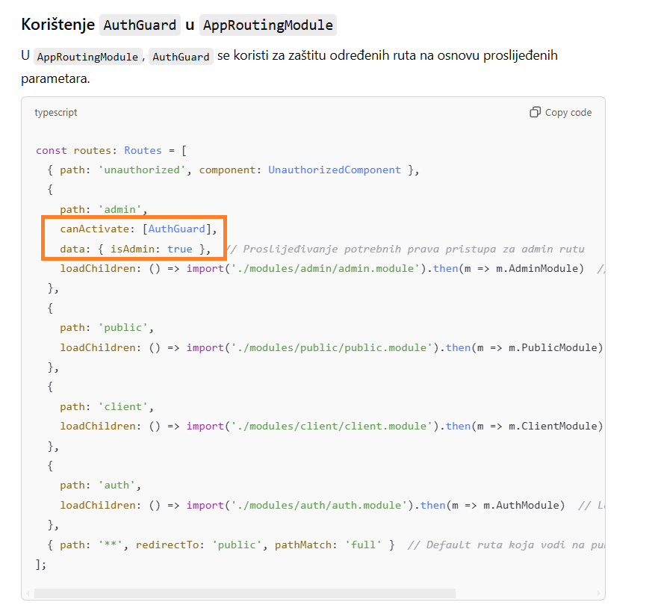

# Angular Reactive Forms

admin\cities1\cities1-edit – **NgModel**

admin\cities2\cities2-edit – **Reactive Forms (podržava naprednije opcije)**

# Angular 19

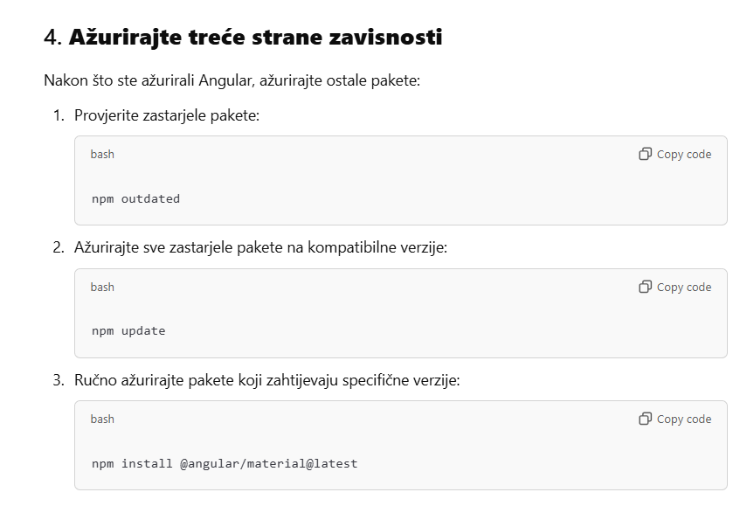

|  |
| --- |
| ng version  npm install -g @angular/cli  ng version  ng update @angular/core @angular/cli --force  npm outdated  npm update  npm install |

U novijim verzijama Angular-a (od verzije **19**), standalone komponente postaju **defaultna konfiguracija** kada je opcija standalone izostavljena. Ovo je dio Angular-ove tranzicije prema modularnijem pristupu bez oslanjanja na NgModule.

**Kako ovo utiče na vaš projekt?**

* Ako niste eksplicitno postavili standalone: false, Angular automatski tretira komponentu kao **standalone**.
* Ovo znači da komponente koje želite koristiti unutar NgModule moraju imati jasno definisano standalone: false ili se moraju koristiti isključivo kroz imports.

|  |  |
| --- | --- |
|  |  |
|  |  |

# Angular material

<https://material.angular.io/guide/getting-started>

**Zadatak 1:**

Kreirati helper dialog

* Simple za ispis obične poruke
* Confirm dialog, npr. delete

<https://material.angular.io/components/dialog/overview>

**Zadatak 2:**

Kreirati helper snackbar

* Simple za ispis obične poruke
* Sa dodatnom opcijom za click

<https://material.angular.io/components/snack-bar/overview>

**Zadatak 3:**

Prepraviti postojeću ngfor tabelu tako da koristi angular material tabelu

* Opcionalnost: koristiti Pagination

<https://material.angular.io/components/table/overview>

**Zadatak 4:**

Kreirati progress bar tipa Indeterminate te ga povezati sa http interceptorom za fetch podataka sa API-a.

<https://material.angular.io/components/progress-bar/overview>